Advanced Programming (Java)

File IO, streams, object serialization

lambdas and regular expressions

in Java

Week 12 – Lecture/Reading and Practice Material

File Class
The File class is an abstract representation of file and directory pathname. A pathname can be either absolute or relative.
The File class have several methods for working with directories and files such as creating new directories or files, deleting and renaming directories or files, listing the contents of a directory etc.
Example 1:
- import java.io.*;
- public class FileDemo {
- public static void main(String[] args) {

- try {
- File file = new File("javaFile123.txt");
- if (file.createNewFile()) {
- System.out.println("New File is created!");
- } else {
- System.out.println("File already exists.");
- }
- } catch (IOException e) {
- e.printStackTrace();
- }

- }
- }

Example 2:
- import java.io.*;
- public class FileDemo2 {
- public static void main(String[] args) {

- String path = "";
- boolean bool = false;
- try {
- // createing new files
- File file = new File("testFile1.txt");
- file.createNewFile();
- System.out.println(file);
- // createing new canonical from file object
- File file2 = file.getCanonicalFile();
- // returns true if the file exists
- System.out.println(file2);
- bool = file2.exists();
- // returns absolute pathname
- path = file2.getAbsolutePath();
- System.out.println(bool);
- // if file exists
- if (bool) {
- // prints
- System.out.print(path + " Exists? " + bool);
- }
- } catch (Exception e) {
- // if any error occurs
- e.printStackTrace();
- }
- }
- }

Java FileWriter and FileReader (File Handling in java)
Java FileWriter and FileReader classes are used to write and read data from text files. These are character-oriented classes, used for file handling in java.
Java has suggested not to use the FileInputStream and FileOutputStream classes if you have to read and write the textual information.

Java FileWriter class
Java FileWriter class is used to write character-oriented data to the file.
Constructors of FileWriter class
Constructor | Description
FileWriter(String file) | creates a new file. It gets file name in string.
FileWriter(File file) | creates a new file. It gets file name in File object.
Methods of FileWriter class
Method | Description
1) public void write(String text) | writes the string into FileWriter.
2) public void write(char c) | writes the char into FileWriter.
3) public void write(char[] c) | writes char array into FileWriter.
4) public void flush() | flushes the data of FileWriter.
5) public void close() | closes FileWriter.

Java FileWriter Example
In this example, we are writing the data in the file abc.txt.
import java.io.*;
class Simple{
public static void main(String args[]){
try{
FileWriter fw=new FileWriter("abc.txt");
fw.write("My name is Ainee");
fw.close();
}catch(Exception e){System.out.println(e);}
System.out.println("success");
}
}
Output:
success...

Java FileReader class
Java FileReader class is used to read data from the file. It returns data in byte format like FileInputStream class. Or we can say character by character.
Constructors of FileWriter class
Constructor | Description
FileReader(String file) | It gets filename in string. It opens the given file in read mode. If file doesn't exist, it throws FileNotFoundException.
FileReader(File file) | It gets filename in file instance. It opens the given file in read mode. If file doesn't exist, it throws FileNotFoundException.
Methods of FileReader class
Method | Description
1) public int read() | returns a character in ASCII form. It returns -1 at the end of file.
2) public void close() | closes FileReader.

Java FileReader Example
In this example, we are reading the data from the file abc.txt file.
import java.io.*;
class Simple{
public static void main(String args[])throws Exception{
FileReader fr=new FileReader("abc.txt");
int i;
while((i=fr.read())!=-1)

System.out.print((char)i);

fr.close();
}
}
Output:
my name is Ainee

FileInputStream and FileOutputStream (File Handling)
In Java, FileInputStream and FileOutputStream classes are used to read and write data in binary file. They are also used for file handling in java.

Java FileOutputStream class
Java FileOutputStream is an output stream for writing data to a file.
If you have to write primitive values then use FileOutputStream. Instead, for character-oriented data, prefer FileWriter. But you can write byte-oriented as well as character-oriented data.

Example of Java FileOutputStream class
import java.io.*;
class Test{
public static void main(String args[]){
try{
FileOutputStream fout=new FileOutputStream("xyz.txt");
String s="Canada is my favourite Country";
byte b[]=s.getBytes();//converting string into byte array
fout.write(b);
fout.close();
System.out.println("success...");
}catch(Exception e){System.out.println(e);}
}
}
Output:success...
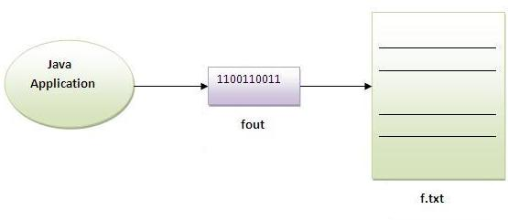

Java FileInputStream class
Java FileInputStream class obtains input bytes from a file. It is used for reading streams of raw bytes such as image data. For reading streams of characters, consider using FileReader.
It should be used to read byte-oriented data for example to read image, audio, video etc.
Example of FileInputStream class
import java.io.*;
class SimpleRead{
public static void main(String args[]){
try{
FileInputStream fin=new FileInputStream("xyz.txt");
int i=0;
while((i=fin.read())!=-1){
System.out.print((char)i);
}
fin.close();
}catch(Exception e){System.out.println(e);}
}
}
Output: Canada is my favourite Country
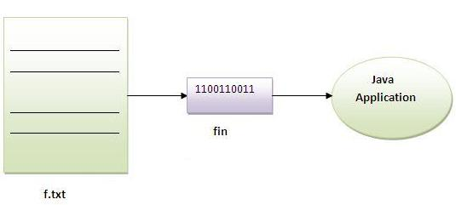

Example of Reading the data of current java file and writing it into another file
We can read the data of any file using the FileInputStream class whether it is java file, image file, video file etc. In this example, we are reading the data of C.java file and writing it into another file M.java.
import java.io.*;
class CopyDemo{
public static void main(String args[])throws Exception{
try{
FileInputStream fin=new FileInputStream("xyz.txt");
FileOutputStream fout=new FileOutputStream("c.txt");
int i=0;
while((i=fin.read())!=-1){
fout.write((byte)i);
}
fout.close();
fin.close();
System.out.println("success...");
}
catch(Exception e)
{System.out.println(e);}
}
}

Serialization
Serialization is a process in which current state of Object will be saved in stream of bytes. As byte stream created is platform neutral hence once objects created in one system can be deserialized in other platform.
As written above serialization will translate the Object state to Byte Streams. This Byte stream can be used for different purpose.
Write to Disk
Store in Memory
Sent byte stream to other platform over network
Save byte stream in DB(As BLOB)
The reverse operation of serialization is called deserialization where byte-stream is converted into an object. The serialization and deserialization process is platform-independent, it means you can serialize an object on one platform and deserialize it on a different platform.
For serializing the object, we call the writeObject() method of ObjectOutputStream class, and for deserialization we call the readObject() method of ObjectInputStream class.
We must have to implement the Serializable interface for serializing the object.

Serialization and Deserialization in Java
Java has already provided out of the box way(java.io.Serializable Interface) to serialize an Object. Via Java Serialization you can stream your Java object to a sequence of byte and restore these objects from this stream of bytes. To make a Java object serializable you implement the java.io.Serializable interface. This is only a marker interface which tells the Java platform that the object is serializable. there is no method in Serializable interface.
Certain system-level classes such as Thread, OutputStream and its subclasses, and Socket are not serializable. If you serializable class contains such objects, it must mark them as "transient".

Code for Serialization of Java Class
Employee.java
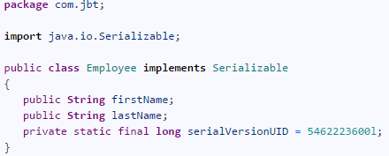

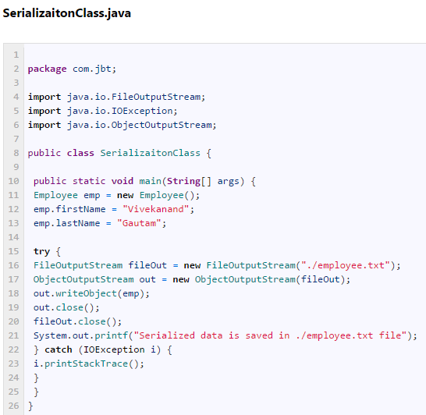
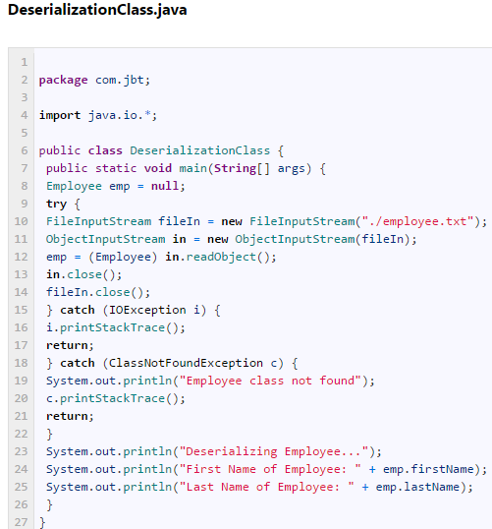
First run “SerializaitonClass” and you will get “employee.txt” file created.
Second run “DeserializationClass” and java will deserialize the class and value will be printed in console.
Output would be
1  2  3  4  5 | Deserializing Employee...  First Name of Employee: Vivekanand  Last Name of Employee: Gautam

Bullet Points
- Serialization interface needs to be implemented in order to make object serialized.
- Transient instance variable doesn’t serialized with Object state.
- If Super class implements Serializable then sub class are also Serializable automatically.
- If Super class is not serializable then when sub class is deserialized then super class’s default constructor will be invoked. Hence all variable will get default value and reference will be null.

Java Serialization- Deserialization Example 1
Create a Java project called "de.vogella.java.serilization". Create the following Java object called Person.
package de.vogella.java.serilization;

import java.io.Serializable;

public class Person implements Serializable {
private String firstName;
private String lastName;
// stupid example for transient
transient private Thread myThread;

public Person(String firstName, String lastName) {
this.firstName = firstName;
this.lastName = lastName;
this.myThread = new Thread();
}

public String getFirstName() {
return firstName;
}

public void setFirstName(String firstName) {
this.firstName = firstName;
}

public String getLastName() {
return lastName;
}

public void setLastName(String lastName) {
this.lastName = lastName;
}

@Override
public String toString() {
return "Person [firstName=" + firstName + ", lastName=" + lastName
+ "]";
}

}
The following code example show you how you can serializable and de-serializable this object.
package de.vogella.java.serilization;

import java.io.FileInputStream;
import java.io.FileOutputStream;
import java.io.ObjectInputStream;
import java.io.ObjectOutputStream;

public class Main {
public static void main(String[] args) {
String filename = "time.ser";
Person p = new Person("Lars", "Vogel");

// save the object to file
FileOutputStream fos = null;
ObjectOutputStream out = null;
try {
fos = new FileOutputStream(filename);
out = new ObjectOutputStream(fos);
out.writeObject(p);

out.close();
} catch (Exception ex) {
ex.printStackTrace();
}
// read the object from file
// save the object to file
FileInputStream fis = null;
ObjectInputStream in = null;
try {
fis = new FileInputStream(filename);
in = new ObjectInputStream(fis);
p = (Person) in.readObject();
in.close();
} catch (Exception ex) {
ex.printStackTrace();
}
System.out.println(p);
}
}

Java Serialization-Deserialization Example 2
Create a Java project called "de.vogella.java.serilization". Create the following Java object called Person.
package de.vogella.java.serilization;

import java.io.Serializable;

public class Person implements Serializable {
private String firstName;
private String lastName;
// stupid example for transient
transient private Thread myThread;

public Person(String firstName, String lastName) {
this.firstName = firstName;
this.lastName = lastName;
this.myThread = new Thread();
}

public String getFirstName() {
return firstName;
}

public void setFirstName(String firstName) {
this.firstName = firstName;
}

public String getLastName() {
return lastName;
}

public void setLastName(String lastName) {
this.lastName = lastName;
}

@Override
public String toString() {
return "Person [firstName=" + firstName + ", lastName=" + lastName
+ "]";
}

}
The following code example show you how you can serializable and de-serializable this object.
package de.vogella.java.serilization;

import java.io.FileInputStream;
import java.io.FileOutputStream;
import java.io.ObjectInputStream;
import java.io.ObjectOutputStream;

public class Main {
public static void main(String[] args) {
String filename = "time.ser";
Person p = new Person("Lars", "Vogel");

// save the object to file
FileOutputStream fos = null;
ObjectOutputStream out = null;
try {
fos = new FileOutputStream(filename);
out = new ObjectOutputStream(fos);
out.writeObject(p);

out.close();
} catch (Exception ex) {
ex.printStackTrace();
}
// read the object from file
// save the object to file
FileInputStream fis = null;
ObjectInputStream in = null;
try {
fis = new FileInputStream(filename);
in = new ObjectInputStream(fis);
p = (Person) in.readObject();
in.close();
} catch (Exception ex) {
ex.printStackTrace();
}
System.out.println(p);
}
}

import java.util.*;
import java.io.*;

public class Rectangle implements Serializable{
private int length;
private int width;

Rectangle (int l, int w)
{
this.length = l;
this.width = w;
}
public void area()
{
double a = this.length * this.width;
System.out.println("Area of the rectangle = " + a);
}
public static void main (String args[]){
try{
//Creating the object
Rectangle r1 = new Rectangle(5,6);
r1.area();
//Creating stream and writing the object
FileOutputStream fout=new FileOutputStream("f.txt");
ObjectOutputStream out=new ObjectOutputStream(fout);
out.writeObject(r1);
out.flush();
//closing the stream
out.close();
System.out.println("success");
}catch(Exception e){System.out.println(e);}

try{
//Creating stream to read the object
ObjectInputStream in=new ObjectInputStream(new FileInputStream("f.txt"));
Rectangle R2=(Rectangle)in.readObject();
//printing the data of the serialized object
System.out.println(R2.length+" "+R2.width);
//closing the stream
in.close();
}catch(Exception e){System.out.println(e);}
}
}

Extra File Reading and Writing Topics (optional)

Reading Ordinary Text Files in Java
If you want to read an ordinary text file in your system's default encoding (usually the case most of the time for most people), use FileReader and wrap it in a BufferedReader.
In the following program, we read a file called "temp.txt" and output the file line by line on the console.
import java.io.*;
public class Test {
public static void main(String [] args) {

// The name of the file to open.
String fileName = "temp.txt";

// This will reference one line at a time
String line = null;

try {
// FileReader reads text files in the default encoding.
FileReader fileReader =
new FileReader(fileName);

// Always wrap FileReader in BufferedReader.
BufferedReader bufferedReader =
new BufferedReader(fileReader);

while((line = bufferedReader.readLine()) != null) {
System.out.println(line);
}

// Always close files.
bufferedReader.close();
}
catch(FileNotFoundException ex) {
System.out.println(
"Unable to open file '" +
fileName + "'");
}
catch(IOException ex) {
System.out.println(
"Error reading file '"
+ fileName + "'");
// Or we could just do this:
// ex.printStackTrace();
}
}
}

Writing Text Files in Java
To write a text file in Java, use FileWriter instead of FileReader, and BufferedWriter instead of BufferedReader. Simple eh? Here's an example program that creates a file called 'temp.txt' and writes some lines of text to it.
import java.io.*;

public class Test {
public static void main(String [] args) {

// The name of the file to open.
String fileName = "temp.txt";

try {
// Assume default encoding.
FileWriter fileWriter =
new FileWriter(fileName);

// Always wrap FileWriter in BufferedWriter.
BufferedWriter bufferedWriter =
new BufferedWriter(fileWriter);

// Note that write() does not automatically
// append a newline character.
bufferedWriter.write("Hello there,");
bufferedWriter.write(" here is some text.");
bufferedWriter.newLine();
bufferedWriter.write("We are writing");
bufferedWriter.write(" the text to the file.");

// Always close files.
bufferedWriter.close();
}
catch(IOException ex) {
System.out.println(
"Error writing to file '"
+ fileName + "'");
// Or we could just do this:
// ex.printStackTrace();
}
}
}
The output file now looks like this (after running the program):
Hello there, here is some text.
We are writing the text to the file.

Reading Binary Files in Java
If you want to read a binary file, or a text file containing 'weird' characters (ones that your system doesn't deal with by default), you need to use FileInputStream instead of FileReader. Instead of wrapping FileInputStream in a buffer, FileInputStream defines a method called read() that lets you fill a buffer with data, automatically reading just enough bytes to fill the buffer (or less if there aren't that many bytes left to read).
Here's a complete example.
import java.io.*;

public class Test {
public static void main(String [] args) {

// The name of the file to open.
String fileName = "temp.txt";

try {
// Use this for reading the data.
byte[] buffer = new byte[1000];

FileInputStream inputStream =
new FileInputStream(fileName);

// read fills buffer with data and returns
// the number of bytes read (which of course
// may be less than the buffer size, but
// it will never be more).
int total = 0;
int nRead = 0;
while((nRead = inputStream.read(buffer)) != -1) {
// Convert to String so we can display it.
// Of course you wouldn't want to do this with
// a 'real' binary file.
System.out.println(new String(buffer));
total += nRead;
}

// Always close files.
inputStream.close();

System.out.println("Read " + total + " bytes");
}
catch(FileNotFoundException ex) {
System.out.println(
"Unable to open file '" +
fileName + "'");
}
catch(IOException ex) {
System.out.println(
"Error reading file '"
+ fileName + "'");
// Or we could just do this:
// ex.printStackTrace();
}
}
}

Writing Binary Files in Java
You can create and write to a binary file in Java using much the same techniques that we used to read binary files, except that we need FileOutputStream instead of FileInputStream.
In the following example we write out some text as binary data to the file. Usually of course, you'd probably want to write some proprietary file format or something.
import java.io.*;

public class Test {
public static void main(String [] args) {

// The name of the file to create.
String fileName = "temp.txt";

try {
// Put some bytes in a buffer so we can
// write them. Usually this would be
// image data or something. Or it might
// be unicode text.
String bytes = "Hello theren";
byte[] buffer = bytes.getBytes();

FileOutputStream outputStream =
new FileOutputStream(fileName);

// write() writes as many bytes from the buffer
// as the length of the buffer. You can also
// use
// write(buffer, offset, length)
// if you want to write a specific number of
// bytes, or only part of the buffer.
outputStream.write(buffer);

// Always close files.
outputStream.close();

System.out.println("Wrote " + buffer.length +
" bytes");
}
catch(IOException ex) {
System.out.println(
"Error writing file '"
+ fileName + "'");
// Or we could just do this:
// ex.printStackTrace();
}
}
}

Wrote 12 bytes

The output file 'temp.txt' now contains:
Hello there

Lambda Expressions
Lambda Expressions were added in Java 8.
A lambda expression is a short block of code which takes in parameters and returns a value. Lambda expressions are similar to methods, but they do not need a name and they can be implemented right in the body of a method.

Syntax
The simplest lambda expression contains a single parameter and an expression:
parameter -> expression
To use more than one parameter, wrap them in parentheses:
(parameter1, parameter2) -> expression

Expressions are limited. They have to immediately return a value, and they cannot contain variables, assignments or statements such as if or for. In order to do more complex operations, a code block can be used with curly braces. If the lambda expression needs to return a value, then the code block should have a return statement.
(parameter1, parameter2) -> { code block }

Using Lambda Expressions
Lambda expressions are usually passed as parameters to a function:
Example
Use a lamba expression in the ArrayList's forEach() method to print every item in the list:
import java.util.ArrayList;

public class Main {
public static void main(String[] args) {
ArrayList<Integer> numbers = new ArrayList<Integer>();
numbers.add(5);
numbers.add(9);
numbers.add(8);
numbers.add(1);
numbers.forEach( (n) -> { System.out.println(n); } );
}
}

Regular Expression
A regular expression is a sequence of characters that forms a search pattern. When you search for data in a text, you can use this search pattern to describe what you are searching for. A regular expression can be a single character, or a more complicated pattern. Regular expressions can be used to perform all types of text search and text replace operations.
Java does not have a built-in Regular Expression class, but we can import the java.util.regex package to work with regular expressions. The package includes the following classes:
- Pattern Class - Defines a pattern (to be used in a search)
- Matcher Class - Used to search for the pattern
- PatternSyntaxException Class - Indicates syntax error in a regular expression pattern

Example
Find out if there are any occurrences of the word "w3schools" in a sentence:
import java.util.regex.Matcher;
import java.util.regex.Pattern;

public class Main {
public static void main(String[] args) {
Pattern pattern = Pattern.compile("w3schools", Pattern.CASE_INSENSITIVE);
Matcher matcher = pattern.matcher("Visit W3Schools!");
boolean matchFound = matcher.find();
if(matchFound) {
System.out.println("Match found");
} else {
System.out.println("Match not found");
}
}
}
// Outputs Match found
Example Explained
In this example, The word "w3schools" is being searched for in a sentence.
First, the pattern is created using the Pattern.compile() method. The first parameter indicates which pattern is being searched for and the second parameter has a flag to indicates that the search should be case-insensitive. The second parameter is optional.
The matcher() method is used to search for the pattern in a string. It returns a Matcher object which contains information about the search that was performed.
The find() method returns true if the pattern was found in the string and false if it was not found.

File Handling Daily Work (Task).
- Implement all the example codes provided.
- Write a Java Code using File handling to count number of characters in a file in Java. Open an already existing text file, read characters, count the number of characters read and display it.
- Use the Shape class hierarchy implemented for QAP3. Just add the code to the demo file to write all the objects created to a file.

References
https://www.javatpoint.com/java-file-class
https://www.w3schools.com/java/java_files.asp
https://www.edureka.co/blog/file-handling-in-java/
Lecture Video Lambdas:
https://www.youtube.com/watch?v=tj5sLSFjVj4
https://www.youtube.com/watch?v=nUIAvs4OEkM
https://www.youtube.com/watch?v=BK5iSG5yMT0
https://www.w3schools.com/java/java_lambda.asp
https://www.geeksforgeeks.org/lambda-expressions-java-8/
Lecture Video Regular Expressions: https://www.youtube.com/watch?v=rhzKDrUiJVk
https://developer.mozilla.org/en-US/docs/Web/JavaScript/Guide/Regular_Expressions
https://www.w3schools.com/java/java_regex.asp
https://www.tutorialspoint.com/java/java_regular_expressions.htm
https://www.javatpoint.com/java-regex
http://javabeginnerstutorial.com/core-java-tutorial/java-serialization-concept-example/

